**Mental Health in Refugee Camps**

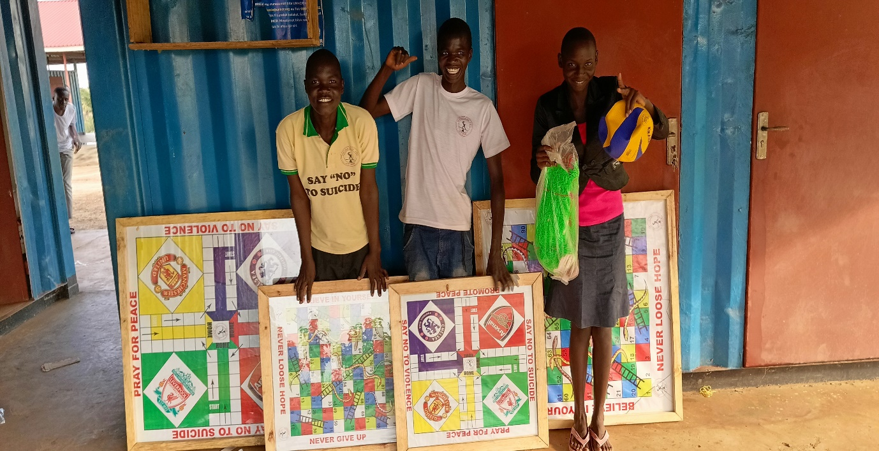

**Introduction**

There are numerous challenges that significantly impact the mental health status of refugees, forced to flee their homes due to conflict, persecution, or natural disasters, they endure traumatic experiences and endure the uncertainty of life in refugee camps. Addressing mental health needs in these camps is a critical yet often overlooked aspect of humanitarian aid. This article explores the mental health challenges faced by refugees in camps and discusses potential solutions.

**Understanding the Mental Health Challenges**

**1. Trauma and PTSD**

Refugees often experience traumatic events such as violence, loss of loved ones, and forced displacement. These experiences can lead to Post-Traumatic Stress Disorder (PTSD), characterized by flashbacks, nightmares, severe anxiety, and uncontrollable thoughts about the trauma. According to a study published in the *Journal of the American Medical Association*, 30% to 70% of refugees experience PTSD symptoms, a significant mental health challenge that requires immediate attention.

**2. Depression and Anxiety**

The uncertainty and instability of life in refugee camps can exacerbate feelings of hopelessness and despair. Limited access to resources, overcrowding, and a lack of privacy contribute to anxiety and depression. A study conducted by the World Health Organization (WHO) found that the prevalence of depression among refugees is 5 to 15 times higher than in the general population, underscoring the need for targeted mental health interventions.

**3. Loss of Identity and Social Support**

Displacement often results in a loss of community, cultural ties, and identity. Refugees may struggle with a sense of belonging and face challenges in adapting to new environments. The breakdown of social support networks further compounds feelings of isolation and alienation, making it difficult for individuals to cope with their new reality.

**4. Stigmatization and Cultural Barriers**

Cultural differences and stigmatization surrounding mental health can prevent refugees from seeking help. In some cultures, mental health issues may be viewed as a sign of weakness, leading to reluctance in acknowledging or addressing these problems. This stigma can hinder access to necessary care and support, perpetuating a cycle of suffering.

**Addressing Mental Health in Refugee Camps**

**1. Integration of Mental Health Services**

Integrating mental health services into primary healthcare systems in refugee camps is essential. Providing training for healthcare workers to recognize and address mental health issues can improve early identification and intervention. The WHO's *Mental Health Gap Action Programme* (mhGAP) offers valuable guidance on integrating mental health care into humanitarian responses.

**2. Community-Based Approaches**

Engaging the refugee community in mental health initiatives can foster trust and understanding. Community leaders and members can play a vital role in raising awareness, reducing stigma, and encouraging individuals to seek help. Peer support programs and community-based counseling can provide a sense of belonging and empower refugees to take charge of their mental health.

**3. Psychoeducation and Trauma-Informed Care**

Providing psychoeducation about mental health can demystify the subject and encourage individuals to seek help. Trauma-informed care, which recognizes the impact of trauma on individuals and adapts services to meet their needs, is crucial in refugee settings. Training healthcare providers in trauma-informed practices can improve the quality of care and ensure that refugees feel safe and supported.

**4. Culturally Sensitive Interventions**

Developing culturally sensitive interventions that respect and incorporate the values and beliefs of refugee communities is essential. Collaborating with cultural mediators and interpreters can bridge communication gaps and ensure that mental health services are accessible and relevant to diverse populations.

**5. Access to Education and Employment Opportunities**

Access to education and employment can significantly impact mental health by providing refugees with a sense of purpose and stability. Skills training programs and educational opportunities can empower individuals and reduce dependency on aid, fostering self-reliance and improving mental well-being.

**Addressing Mental Health in Palorinya Refugee Camps**

**1. Integration of Mental Health Services**

Integrating mental health services into primary healthcare systems in refugee camps is essential. Providing training for healthcare workers to recognize and address mental health issues can improve early identification and intervention. Access to Mental healthcare, physical health services will reduce barriers to care and promoting holistic well-being.

**2. Community-Based Approaches**

Engaging the refugee community in mental health initiatives can foster trust and understanding. Community leaders and members can play a vital role in raising awareness, reducing stigma, and encouraging individuals to seek help. Peer support programs and community-based counselling can provide a sense of belonging and empower refugees to take charge of their mental health. By involving refugees in the design and implementation of mental health programs, these initiatives can be more culturally sensitive and responsive to the specific needs of each community.

**3. Psychoeducation and Trauma-Informed Care**

Providing psychoeducation about mental health can demystify the subject and encourage individuals to seek help. Trauma-informed care, which recognizes the impact of trauma on individuals and adapts services to meet their needs, is crucial in refugee settings. Training healthcare providers in trauma-informed practices can improve the quality of care and ensure that refugees feel safe and supported. This approach emphasizes the importance of understanding trauma's effects on individuals and communities, fostering an environment of safety and healing.

**4. Culturally Sensitive Interventions**

Developing culturally sensitive interventions that respect and incorporate the values and beliefs of refugee communities is essential. Collaborating with cultural mediators and interpreters can bridge communication gaps and ensure that mental health services are accessible and relevant to diverse populations. Tailoring interventions to reflect the cultural practices and traditions of refugees helps build trust and encourages participation in mental health programs.

**5. Access to Education and Employment Opportunities**

Access to education and employment can significantly impact mental health by providing refugees with a sense of purpose and stability. Skills training programs and educational opportunities can empower individuals and reduce dependency on aid, fostering self-reliance and improving mental well-being. Providing pathways for refugees to pursue education and employment enables them to build futures for themselves and their families, contributing positively to their mental health and well-being.

**What has Psycho Plus CBO done**

**1. Palorinya Refugee Camp**

The implementation of community-based mental health programs by Psycho Plus CBO has yielded positive results. These initiatives focus on engaging refugees in activities that promote mental well-being, such as art therapy, sports, and training. By addressing the social determinants of mental health, these programs have improved the overall quality of life for camp residents.

**2. Psycho Plus Psychosocial Support Programs**

Psycho Plus CBO has implemented successful psychosocial support programs in Palorinya settlement, targeting children and adolescents. These programs provide safe spaces for young refugees to express themselves, build resilience, and develop coping skills. By focusing on early intervention, these initiatives aim to prevent the long-term impact of trauma on young minds.

**Conclusion**

Addressing mental health in refugee camps is a complex but essential component of humanitarian aid. By recognizing the unique challenges faced by refugees and implementing culturally sensitive, community-based interventions, we can create environments that promote mental well-being and resilience. As the global refugee crisis continues, prioritizing mental health care in refugee camps is a moral imperative and a crucial step towards building a more compassionate and inclusive world.